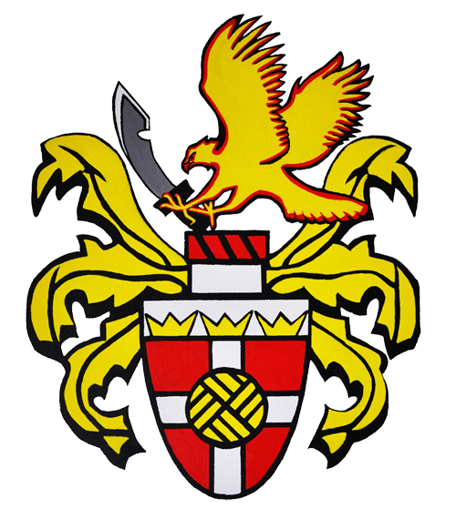 HARLOW TOWN FC
The Harlow Arena, Elizabeth Way, Harlow, Essex, CM19 5BE

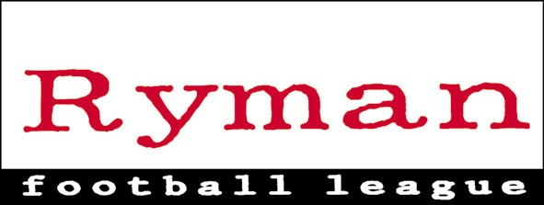

EARLY BIRD OFFER FOR SEASON TICKETS 2015/16

Season tickets purchased before Midday on Saturday 18th April 2015 are on sale.
Season Tickets sold after Midday on Saturday18th April 2015 could be subject
to an increase.

The Season tickets entitles the holder to admission for all home Ryman league games
during the course of the 2015-16 season and home Pre Season Friendly’s.

Season tickets prices are as follows:
Adult £180
Concession £125 (Over 60)
Evidence may be requested (e.g. Travel Pass/Passport),
Under 16 £10
Proof of age may be requested.

These prices represent a considerable saving on current general match-day
Admission prices of £10 for adults, £7 for concessions and £1 for Under 16’s
Which will be reviewed for 2015-16

To purchase a season ticket, please complete the form below and send it along
With your payment to Jill Dumoulin, Harlow Town Football Club, The Harlow Arena,
Elizabeth Way, Harlow, Essex, CM9 5BE or E-Mail jill@theharlowarena.co.uk
Or contact an official at any home or away game.

Cheques made payable to “Harlow Town Football Club” please.
-----------------------------------------------------------------------------------------------------------

Harlow Town Football Club Early Bird Season Ticket request 2015-2016

Name: _____________________________________________________

Address: _____________________________________________________

Contact phone number: __________________________________________

Adult ( ) OAP ( ) Under 16 ( )

Please tick appropriate brackets

